LangGraph Math Agent

Overview
This project implements a simple agent that routes user queries to either:
1. Local math tools (addition, subtraction, multiplication, division), or
2. A local LLM running in Ollama for general questions.
The agent detects math queries using a lightweight parser and routes them through a custom flow similar to a LangGraph-style architecture.
This project runs entirely on a local machine without any paid API keys.

Features
- Detect mathematical queries such as "10 - 4", "How much is 50 minus 25"
- Compute results using predefined Python functions.
- For all non-math queries, forward text to local Ollama model.
- Safe error handling for divide-by-zero and invalid parse cases.

Folder Structure:
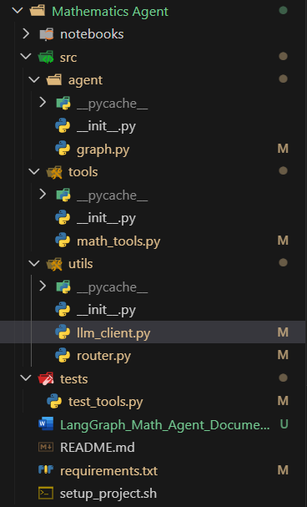

Setup
1. Download the project folder.
2. Create and activate virtual environment:
python -m venv .venv
.venv\Scripts\activate (Windows)
source .venv/bin/activate (Linux/Mac)
3. Install required packages:
pip install -r requirements.tx
4. Ensure Ollama is installed and the model is pulled:
ollama pull llama3.2:3b

Running the Agent:
Run from project root:
python -m src.agent.graph
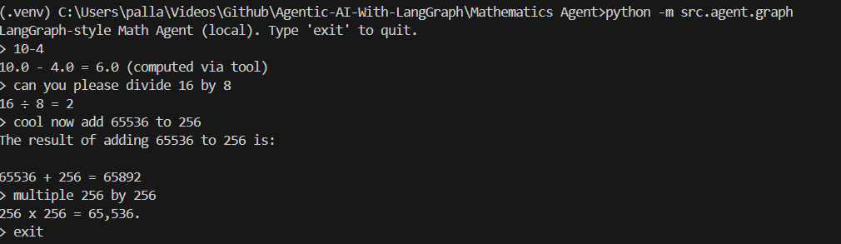

Usage Examples:
Math queries:
10 - 4
What is 5 plus 3
multiply 4 and 8
divide 20 by 5

General queries:
Who is Albert Einstein
Explain machine learning
What is LangGraph
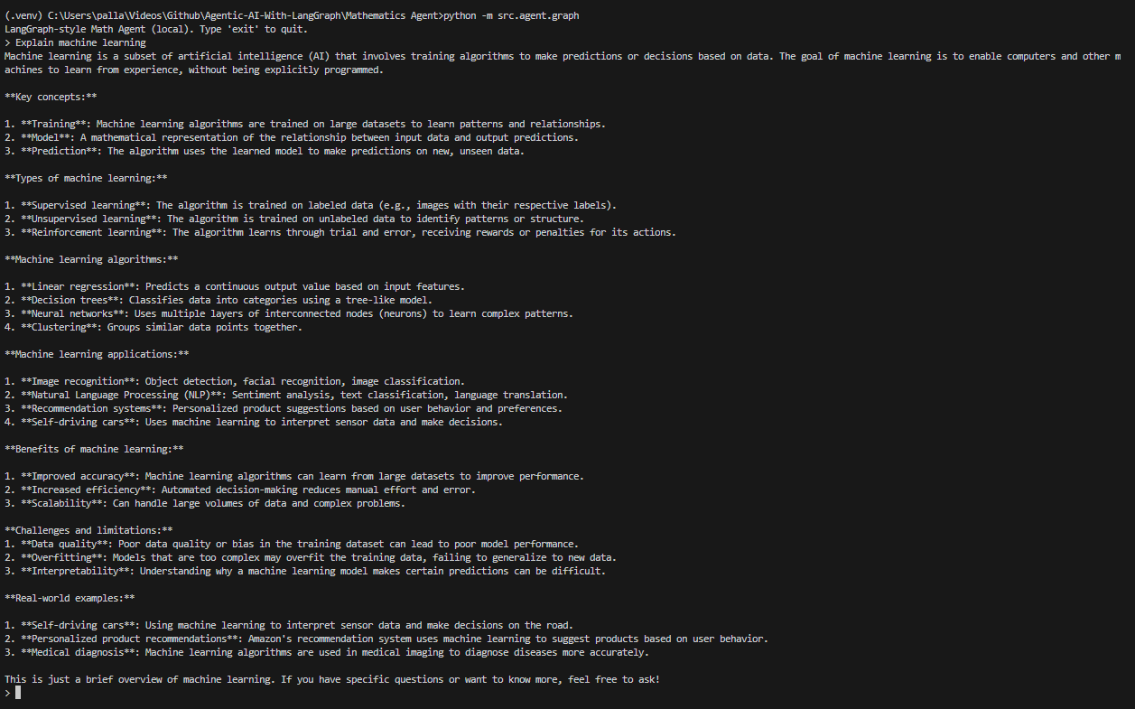

Techniques Used:
1. Custom math tools
2. Math query detection (router)
3. Query routing
4. Local LLM execution
5. Error handling

Conclusion:
This project demonstrates a lightweight LangGraph-style agent that mixes tool usage and LLM reasoning. All components run locally.

